**Knowledge Discovery and Management**

**Project Report**

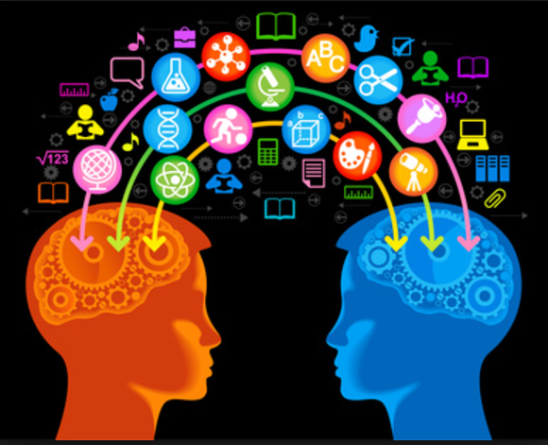

TechChamps

**Team 1**

1. Jakkepalli Rama Charan Pavan (8)
2. Puthana Sujitha (24)
3. Yalamanchili Sowmya (30)
4. Nandanamudi Sreelakshmi (17)

# 1.Project Motivation, Objectives, and Significance

**1.1 Motivation:**

Data Science is a system to extract knowledge of data in various forms, either structured or unstructured from various domains, similar to Knowledge Discovery in Databases(KDD). Natural language processing is used for processing the text which is machine understandable and which will help for fast retrieval of data.

* 1. **Specific Objectives:** 
     1. **Easy search of information from huge amount of text.**

In present days, the amount of data is increasing and this is leading to the difficulties in handling the data. So we need the machine learning algorithms to handle these huge data. We are making use of artificial intelligence allogorithm for machine learning to handle data and search the data.

* + 1. **Helps in precise answer for customized questions.**

As we are using these AI algorithm for handling data, this helps in getting through different algothms available including TFIDF, NLP algorithms, word2vec algorithm, kmean algorithm, classification of data using all these process and analyzing the accuracy. This tremendous process leads to precise answer of the question.

* + 1. **Increase the knowledge management process.**

In the process of going through different AI algorithm to classify data and handle them. We could understand the importance of each algorithm with the specified uniqueness. By making using use of all these algorithms simplify the management of data.

**1.3 Specific Significance:**

This application helps in fetching the answer to particular questions by using NLP Process, word2vec, TF-IDF, N-gram. NLP , kmean, Classification of data, NLP algorithm is useful step for text processing and then we are extracting the relevant data.

However all the algorithm we are using in the project have its own significance.Comapring all these process to find the best process with respect to time, accuracy, cost to select the best process.

**2. Domain and Q/A application**

We are taking News as our domain for our project and applying NLP operations on it and further applying question answering system for the dataset. For this question answering system, we are considering two datasets from News domain.

Question and answer application is build where a user can ask question like what, why, who, when related to the domain dataset. Then the algorithm is implemented to search the huge data. With very high processing speed and high accuracy, we will fetch the precise answer and display it to the user.

**3. Related Work:**

In the present days, where the data is huge leading to data management issues.There are many algorithm already existing but the main problem in the existing algorithms are completemess and correctness. To solve this problem we need to consider all these algorithm and judge wisely which all are the algorithms that we can use to easily maintain data and give us the high accuracy.But a single algorithms or approach cannot solve this probem. Hence we should integrate multiple algorithm for high accuracy in desiging the search engine.

Searching the huge amount of data is very difficult. Knowledge Graph represents the graphical representation of the entities and interrelated relationship. There are different knowledge graph available in the market but googles knowledge graph is the popular search engine algorithm. Best knowledge graph can be designed solving the completeness and correctness issue by integrating different approaches of knowledge graph available in the market.

Data souces that are available to us are limited. We can increase the accuracy to provide the best awswer to any question is by considering all the data souces that are available on the web. The soluction for this approach is the knowdege vault that was made available to us by google that takes the data in RDD triplets i.e., subject, object, predicate. After collecting the data and finding the entities our next problem would be organizing the data. We Deep Dive approach helps in resolvng the problem of extraction of data and its integration to fetech accurate prediction making the training process easy.

After the data is represented in RDF triplets, the semantic relationship can be organized using the FehSen to merge the related information leading to more simplified data. It is known fact that structured data is easy to handle than unstructured data. Fonduer is the approach in focusing the contruction of the structured data from the plain text. By using all these approach helps in improving the handling the data and solve the “completeness and correctness” problem.

**4. Specific Datasets**

For our project implementation, we have considered two datasets as follows:

* WikiRef220
* WikiRef220 is the collection of the news article, taken from the Wikipedia pages.
* This dataset includes the information in the form of text data.
* The articles included in this dataset are November 2015 paris attack, Flight 370 Malaysian Airlines, premier league, Michelle Obama, Samsung Galaxy.
* BBC News-In this especially we have selected politics area and sports.
* This datasets includes the news article from collected from BBC.
* This dataset was made available mainly for machine learning research. We are using this dataset for our process.
* We mainly selected the pollical area and sports area of the BBC news dataset.

**5. Design**

**5.1 Workflow**

Step 1: Natural language processing – This process includes the identification of token, lemmatization, named entity reference(NER), co-reference resolution.

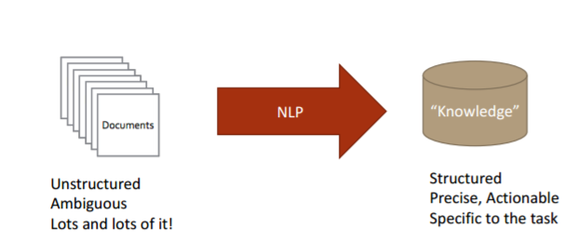

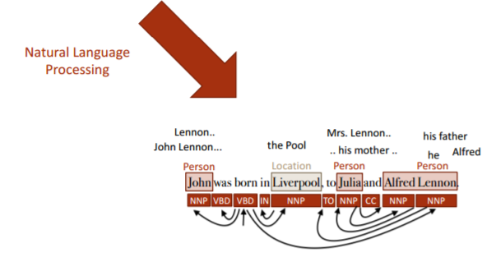

Step 2: Information Retrieval – Retrieving the information from the text. We are including the identification of the NER i.e., PERSON, LOCATION, ORGANIZATION.

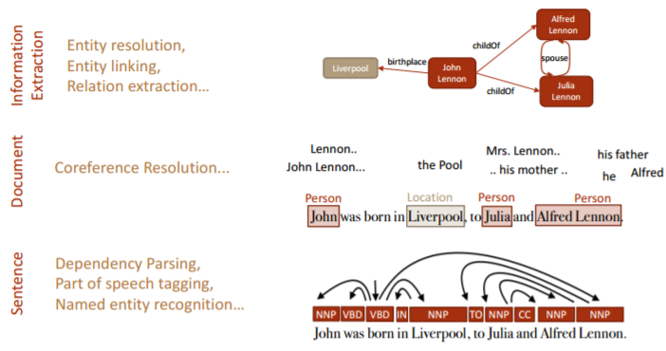

Step 3: Topic Discovery – Topic discovery helps identification of the topics from the context question.

Step 4: Knowledge Graph construction – Construction of the knowledge graph from generated NER.

**5.2 NLP**

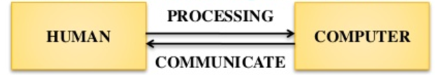

Natural Language Processing is the process that’s makes the computer to understand, analyze and extract meaning from human understandable language in a useful and smart way. NLP algorithms helps the organizing and to structure data in order to perform automatic aummarization, named entity recognization, translation, relationship extraction, speech recognization, sentiment analysis, topic segmentation.

Steps in NLP designing:

* Tokenization – Break the text data into sentence, words.
* Lemmatization – Recognizing the base form of word.
* Morphology – Includes Part of Speech reconization , stemming i.e., excluding the postfix words to get the base root word, Named entity recognization.
* Syntax – Parsing Constituency or dependency
* Semantic – Coreference resolution i.e., finding the context that belongs to same entity.

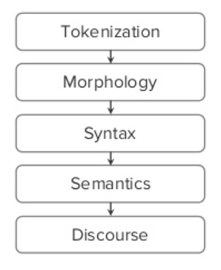

**5.3 Information Retrieval**

Information retrieval is the process of tracing through the stored data and recoving specific information from huge amount of stored data. It is very difficult to find the specific data from such a huge amount of data. So we are using the below approaches to simplify the information retrieval process.

**5.3.1 Term Frequency Inverse Document Frequency(TFIDF)**

TFIDF is the numerical weight of the tokenized word that demonstrate the importance of the word in the huge document. The weight of the word increses with the repeteation of word in the document. TFIDF is can be represented as TF*IDF i.e., product of term frequency i.e., occurrence of word in a particular document and Inverse document frequency i.e., log value number of document the word exists divided by the total number of documents.

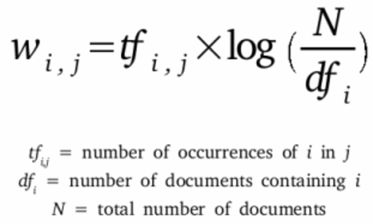

**5.3.2 Word2Vector**

Word2Vec is the process of construction of the vector from the huge text document.

**5.4 Information Extraction**

**5.4.1. OpenIE**

**5.4.2 WordNet**

**5.5 Machine Learning**

**5.5.1 Clustering**

**5.5.2 Classification**

**5.6 Knowledge Graph**

Knowlwdge Graph is used to simplify the search results. This graph represent the graphical representation of the flow of the text data. The main advatange of using this knowledge graph is simplified diagrammatical representation of the huge data, helps in easy knowledge transfer and documenetaio easy.

**5.2.1 Design workflow of knowledge Graph**

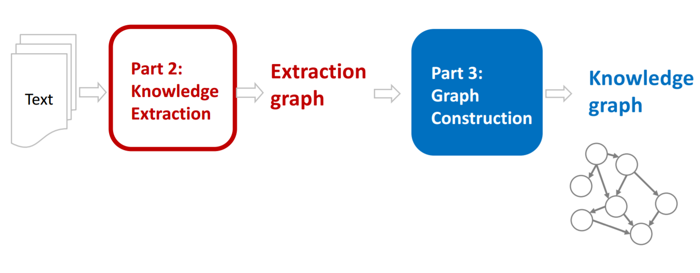

Steps followed in desiging this knowledge graph:

1. Recognizing the named entity reference including the people, organization, location, date etc.
2. Desiging the data schema i.e., finding the relationship between these entities.
3. Representing them in diagramical graph

**5.2.2 Knowledge Graph for our dataset:**

We do not have any specified rules for desiging this knowledge graph. Different companies have there own knowedge graph construction and follows there own rules.

Below is the diagrammatical representation of the knowledge graph that is designed for our datasets.

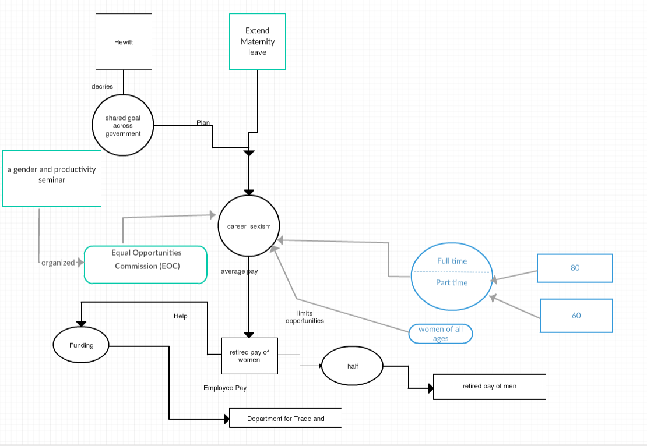

**5.3 A Question-Answer Set for our Dataset.**

We are designing the questions from datasets considering mainly the PERSON, LOCATION, ORGANIZATION, NUMBER entity.

1. When was Obama born?

Born on Aug. 4, 1961.

1. Where did Obama did his schooling?

Punahou School.

1. Who is father of Obama?

Barack Hussein Obama.

1. Whom did Obama compete in primary race?

Hillary Rodham Clinton.

1. What is the minimum duration for maternity leave?

6 months.

1. What is the topic about?

career sexism.

1. Who is the speaker?

Ms. Hewitt.

1. What is the average pay for full-time women.

80p

1. What is the average pay for part-time women.

60p.

1. What is the average pay for retired women compared to men?

Half.

# 6. Implementation

**6.1 Output of NLP operations for our dataset**

We have performed the NLP operations on the dataset which we have chosen and the result of each operation is shown in the below mentioned screenshots.

Tokenization:

Lemmatization:

POS Tagging:

NER:

Coreference Resolution:

Below is the code for all the operations of the NLP.

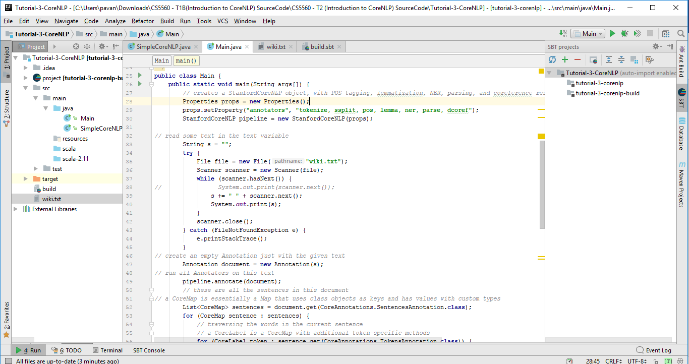

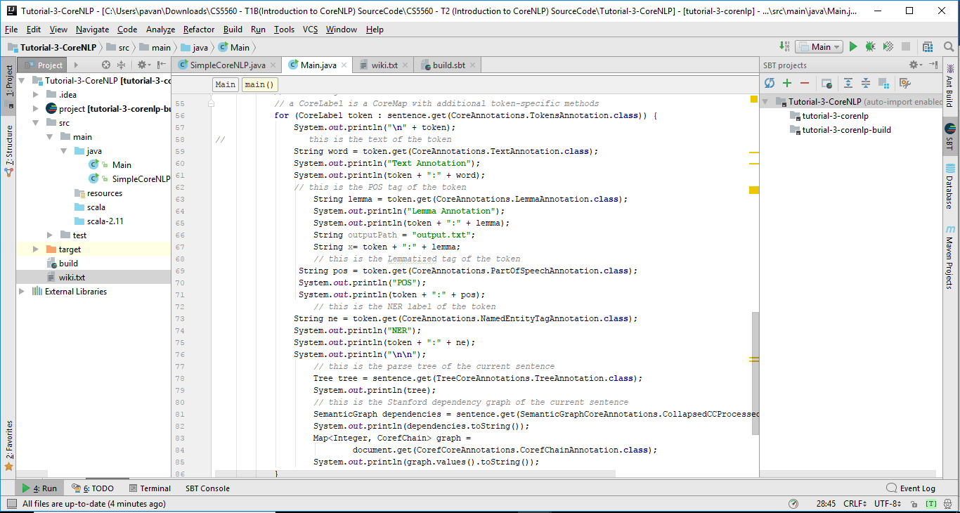

Below are the outputs of the operations.

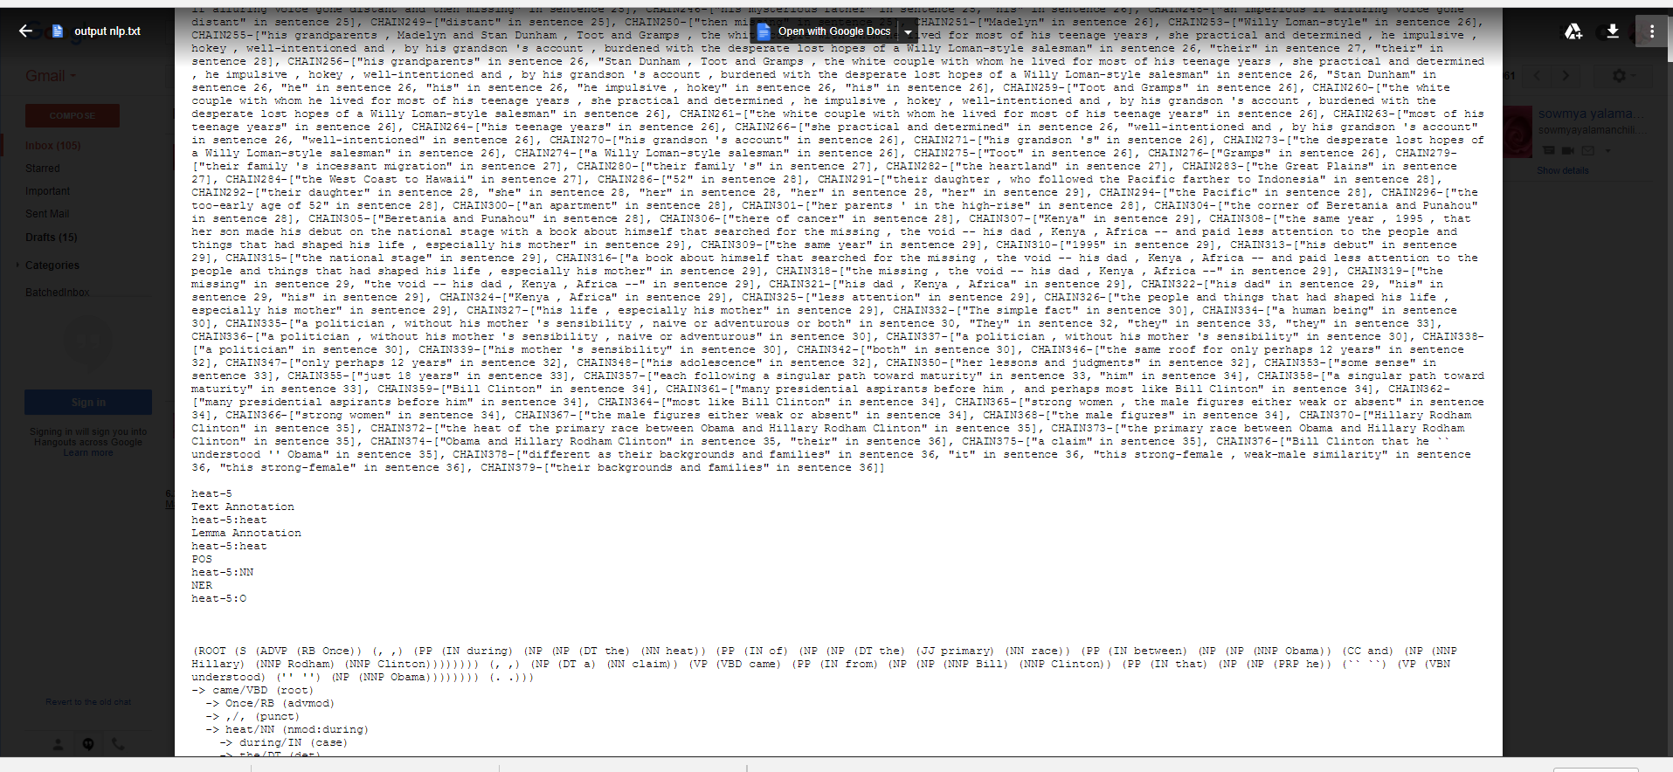

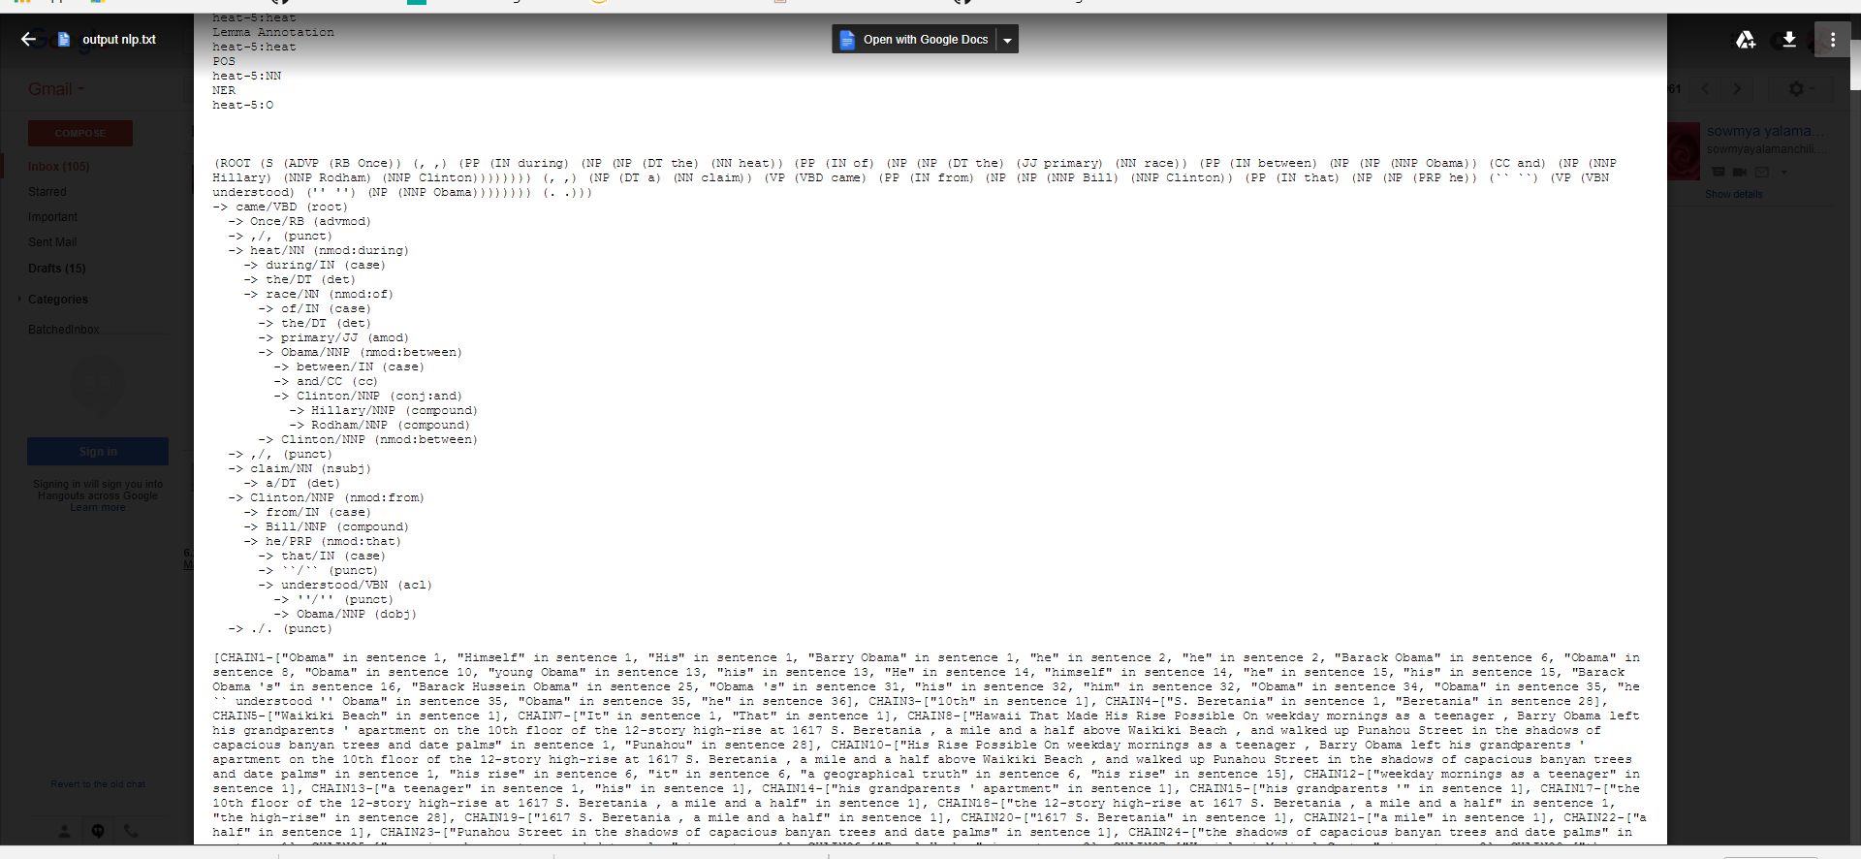

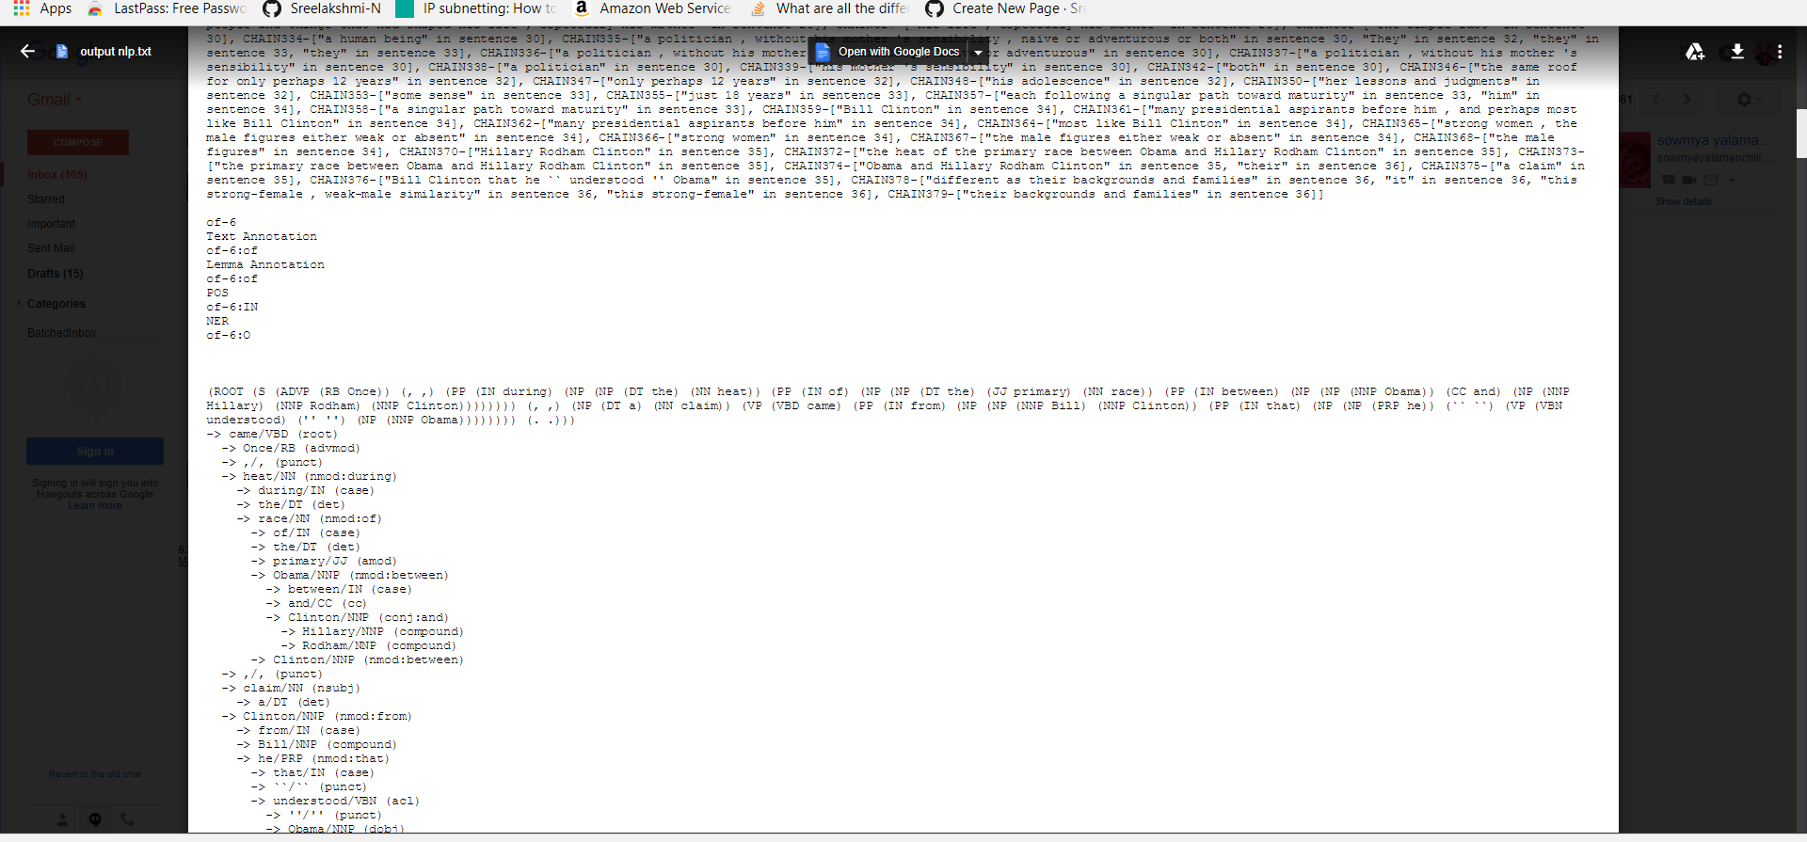

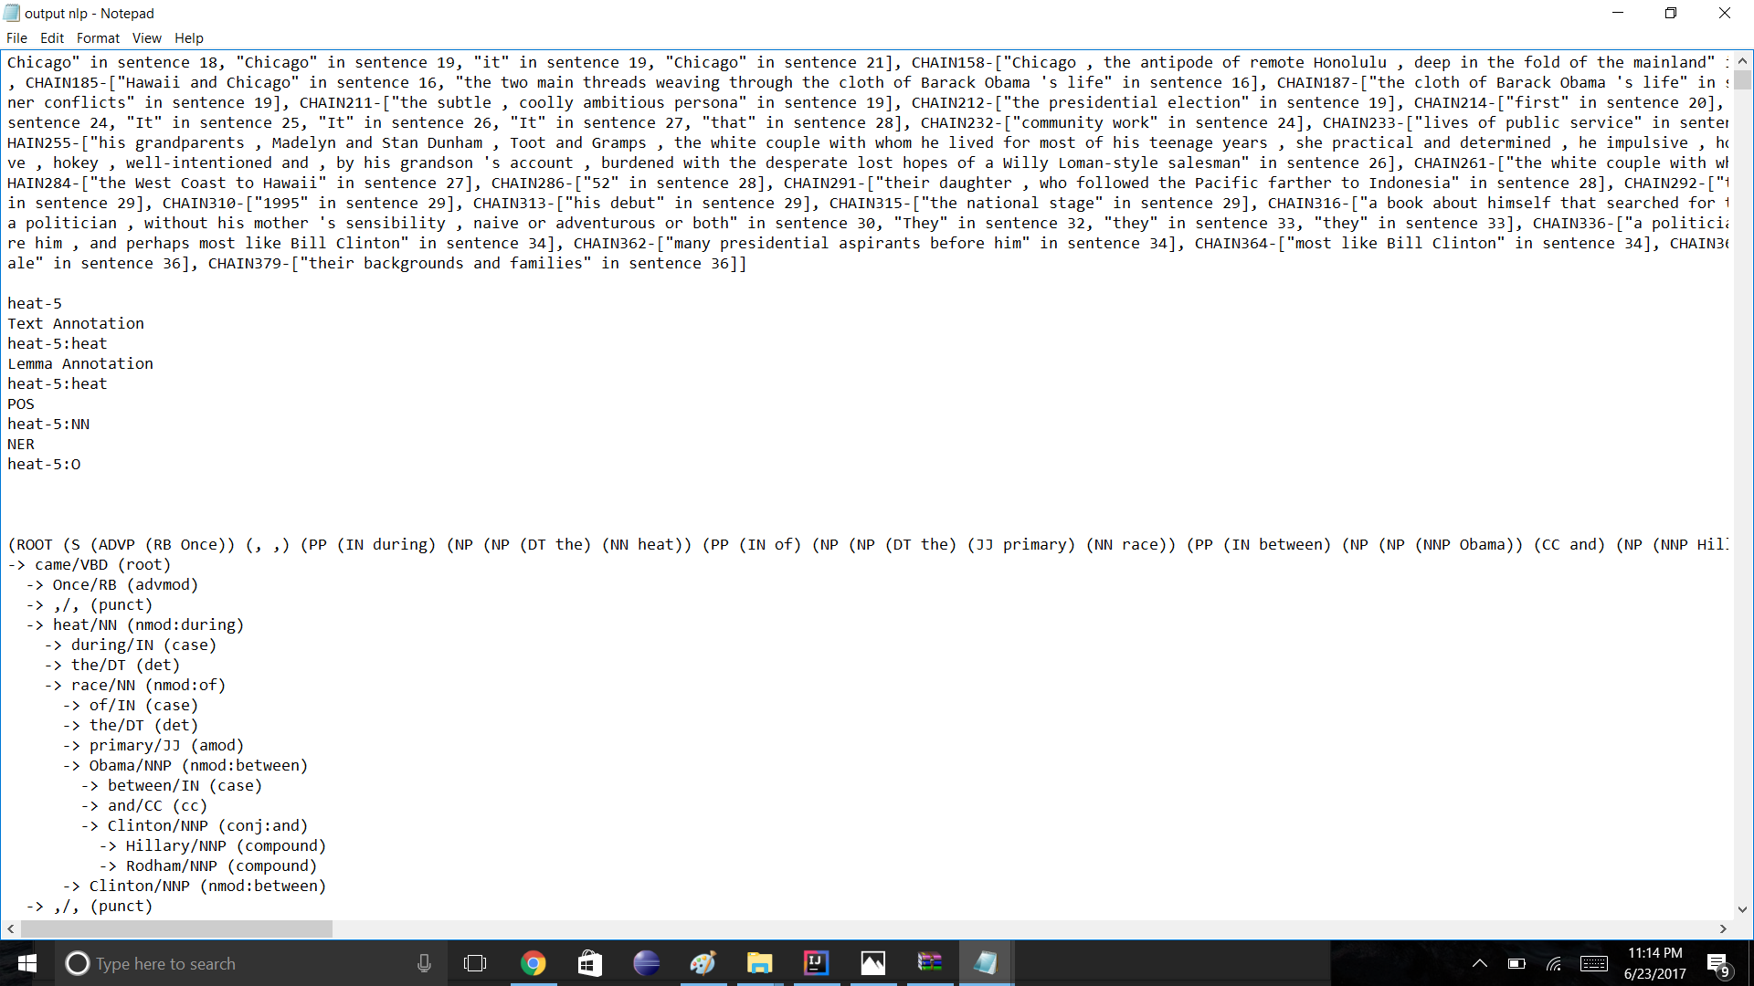

**6.2 Question Answering for our dataset**

After performing the NLP operations, we have taken the post processed dataset and we have separately stored the result of NER output like from the NER result we have the all person related entities to one file and similarly we have done for every group and based on that we have generated answers for the questions we choose. The below screenshots will depict the same.

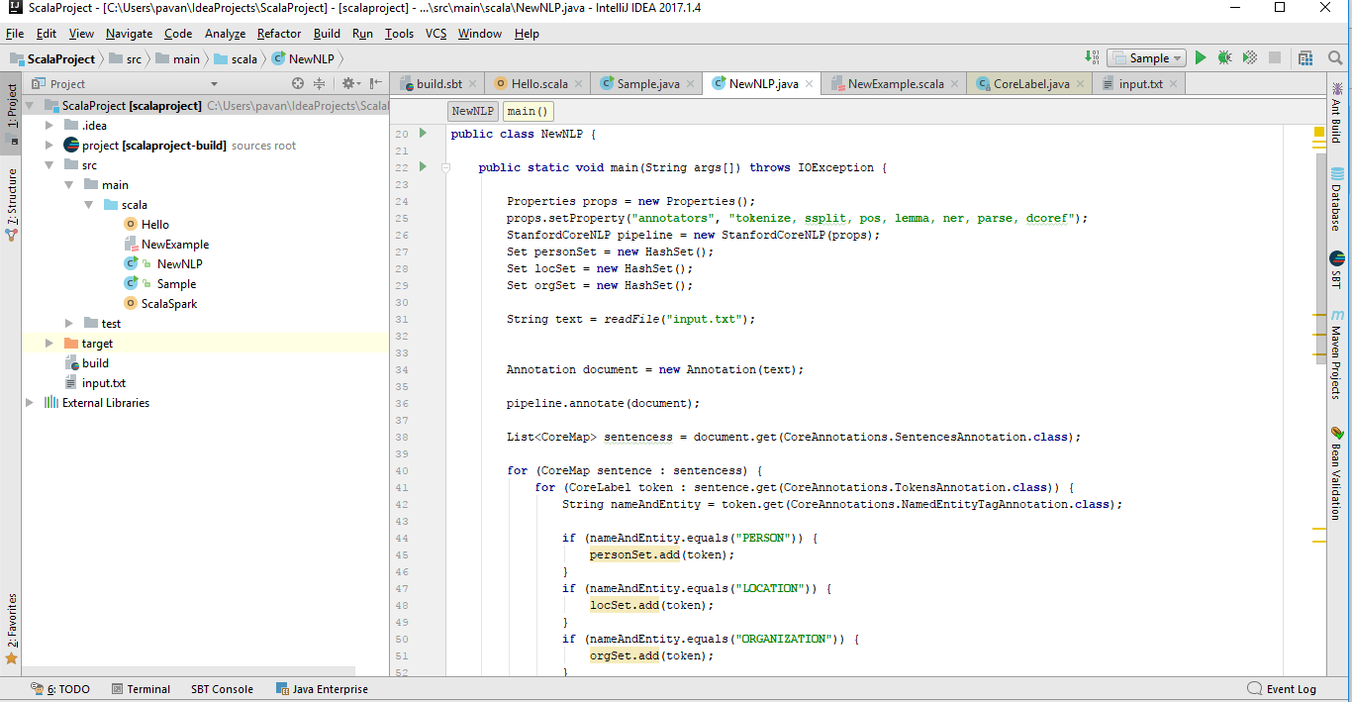

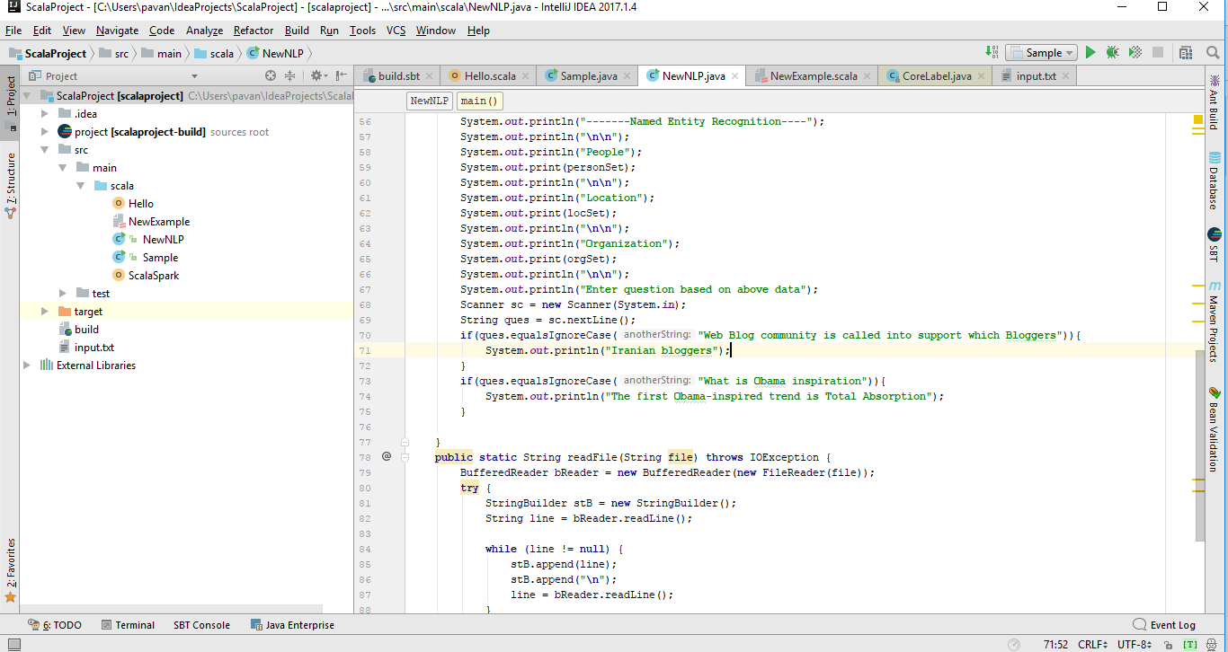

The below screenshot shows the output of our dataset which was categorized into different NER tags. When we compose a question, the corresponding answer will be taken based on the list of the NER entities.

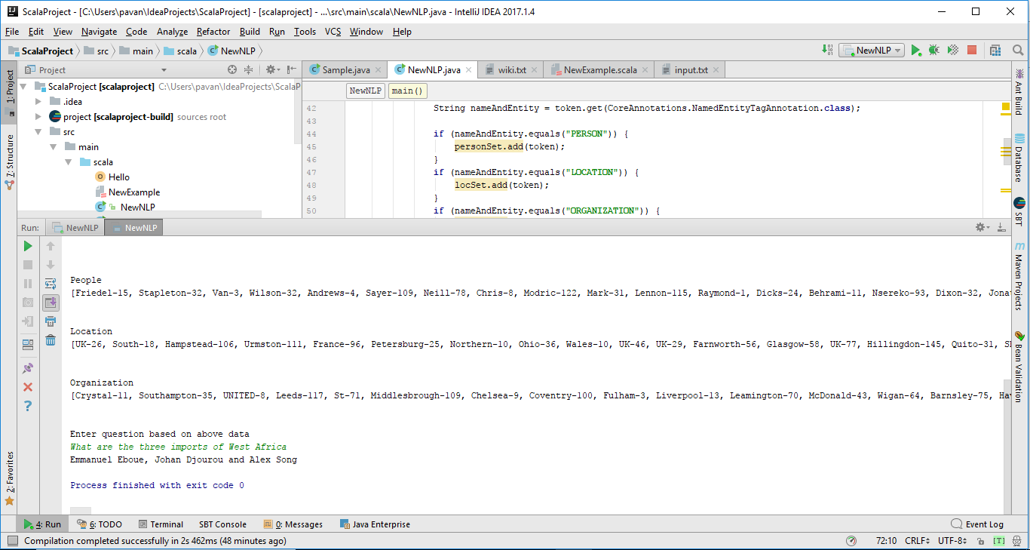

**6.3 TF-IDF for our dataset**

Generating the term frequency for the words in the dataset.

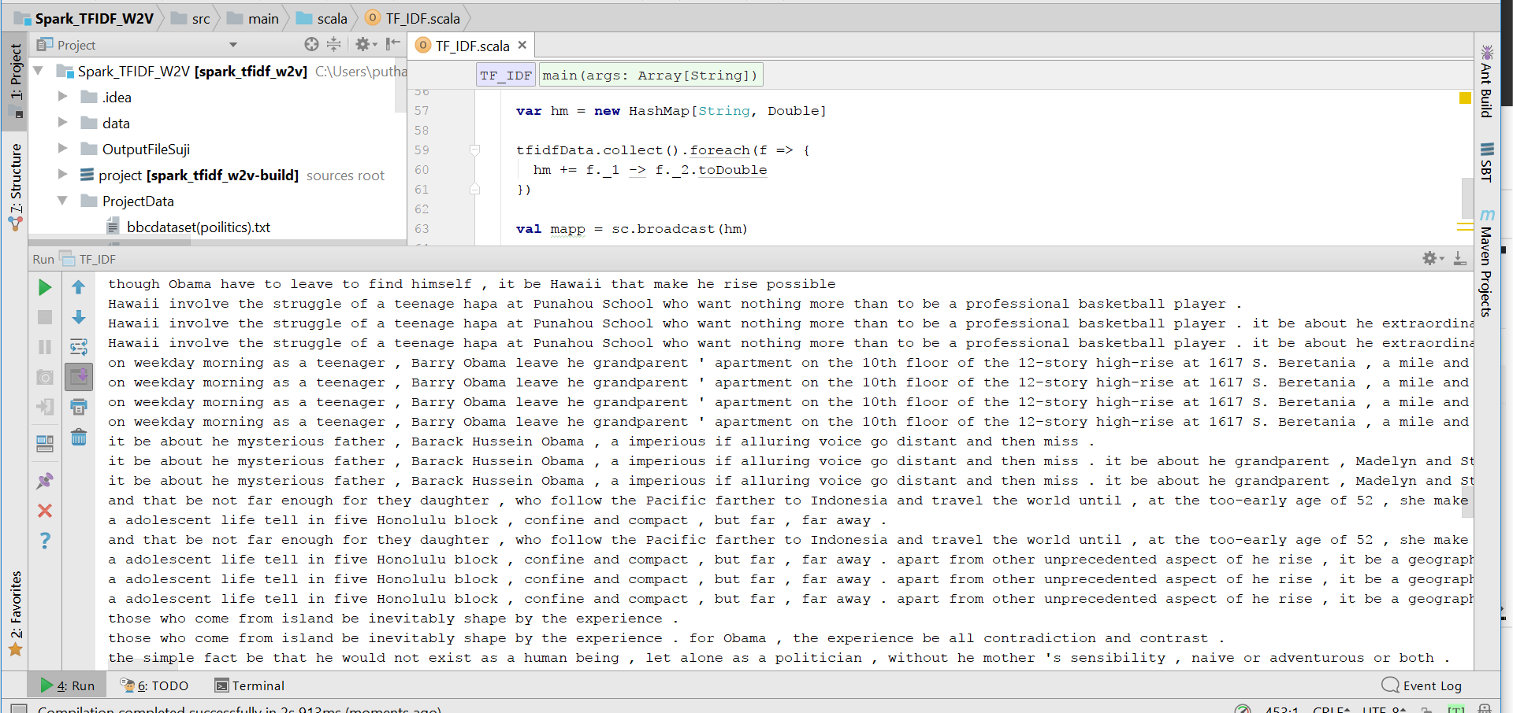

Generated Output.

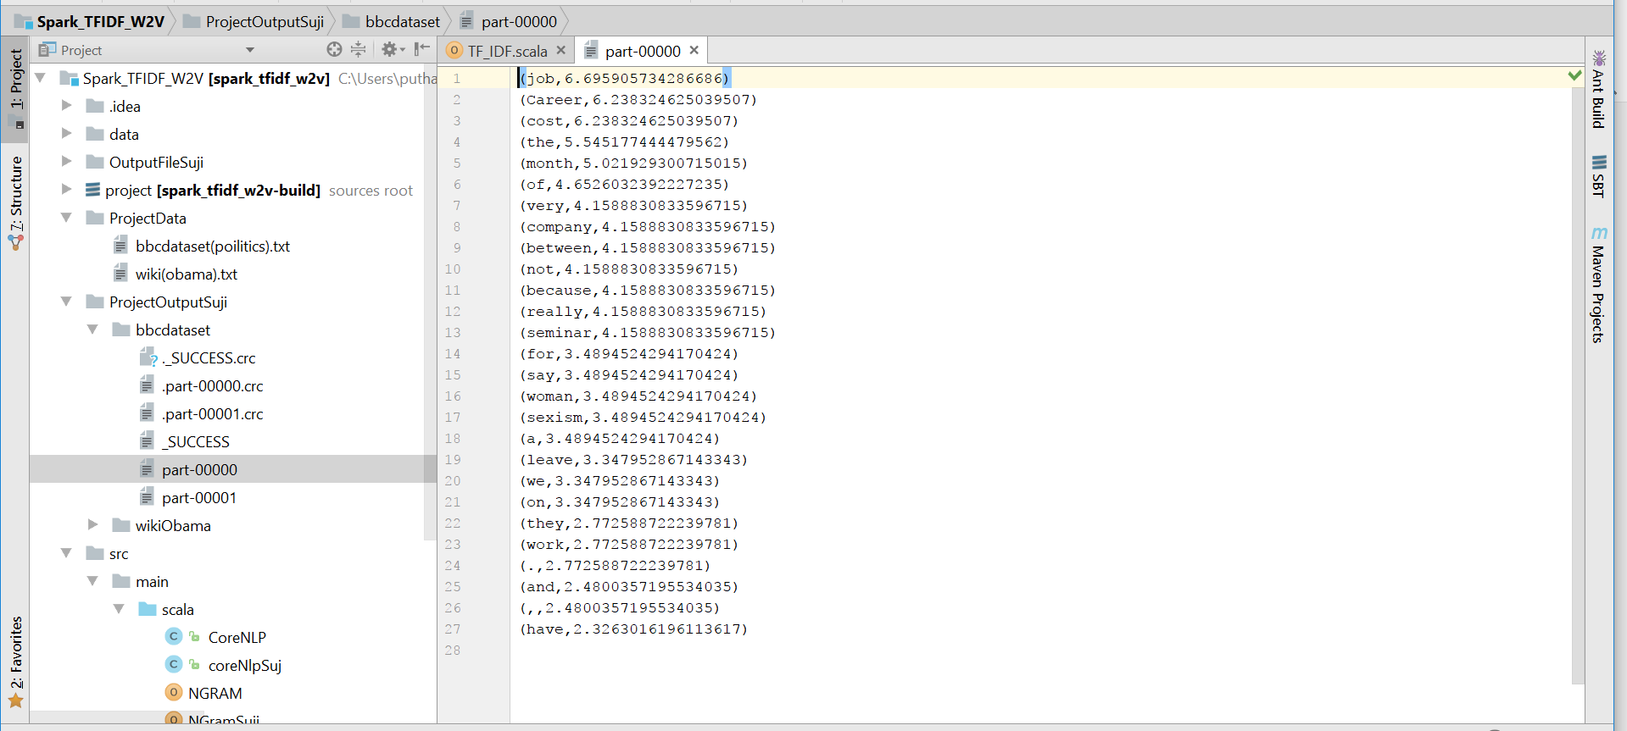

Generation N-gram for the dataset

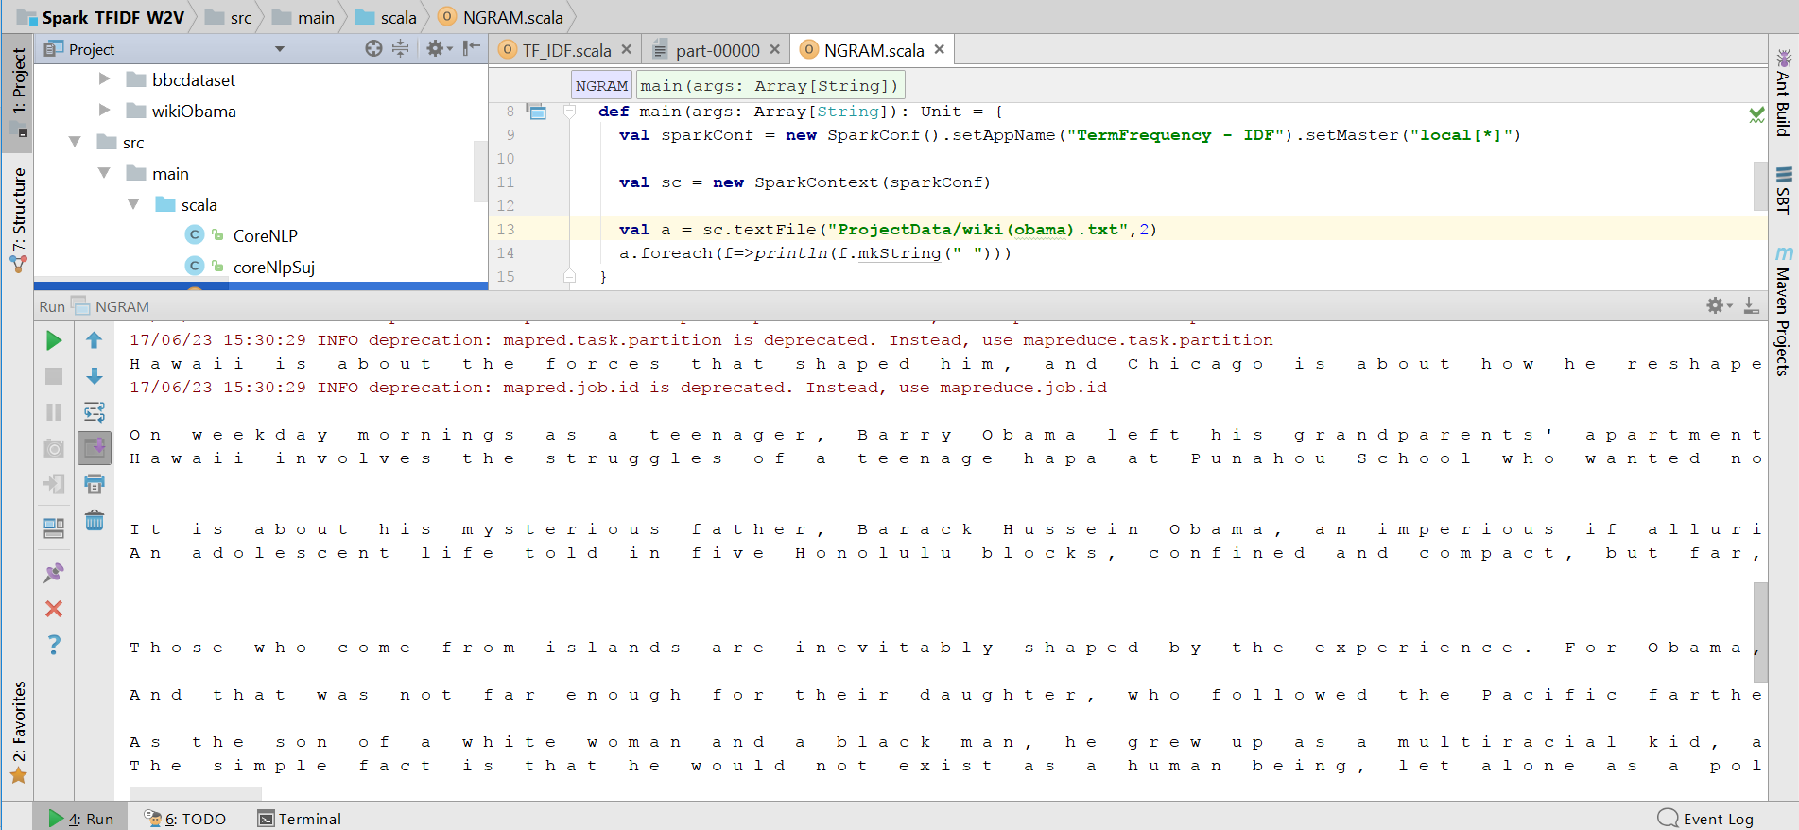

Generating the TF_IDF for N-gram output.

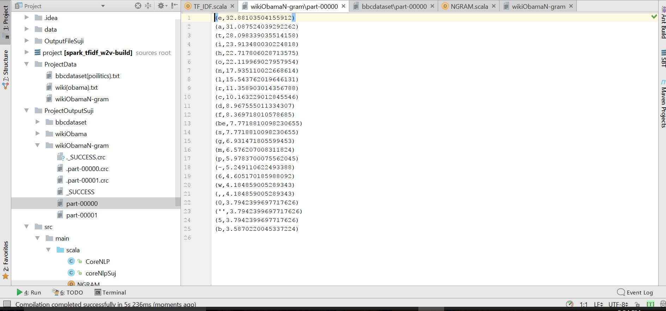

**6.4 Information Extraction**

**OpenIE for our dataset:**

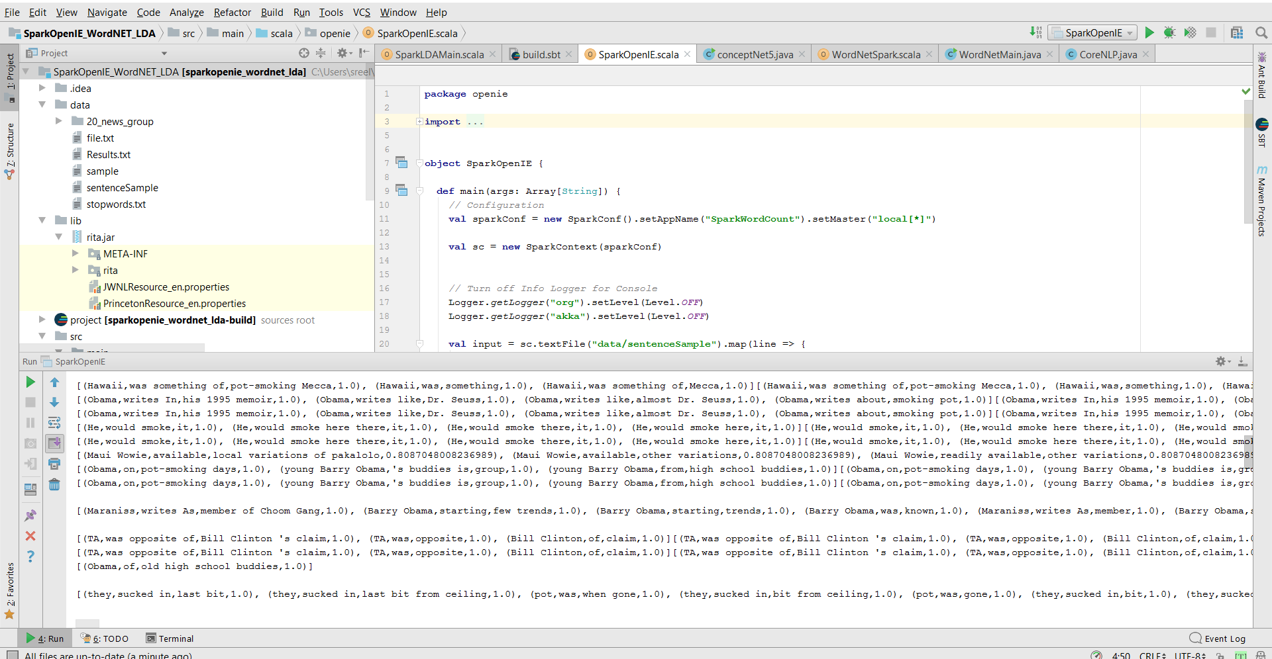

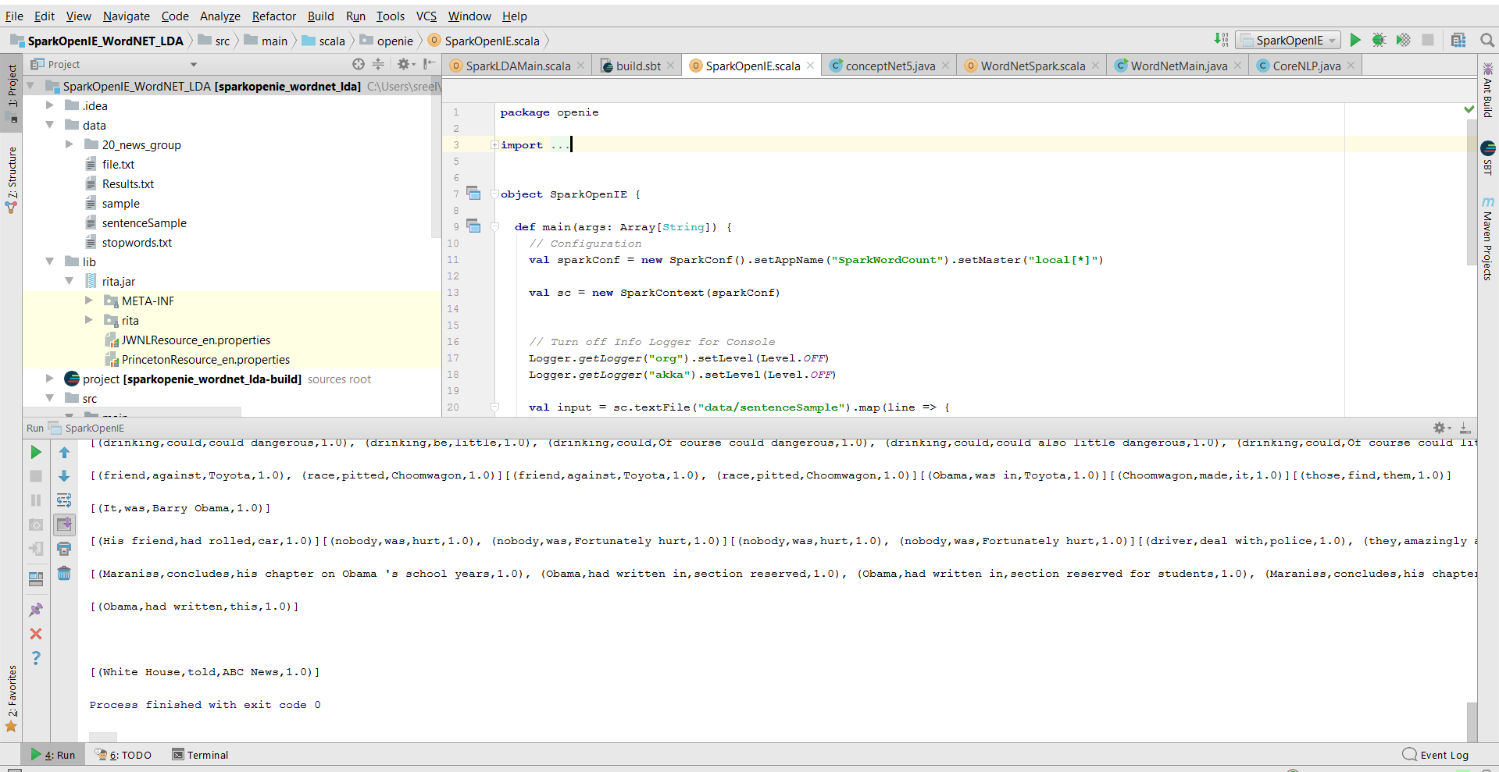

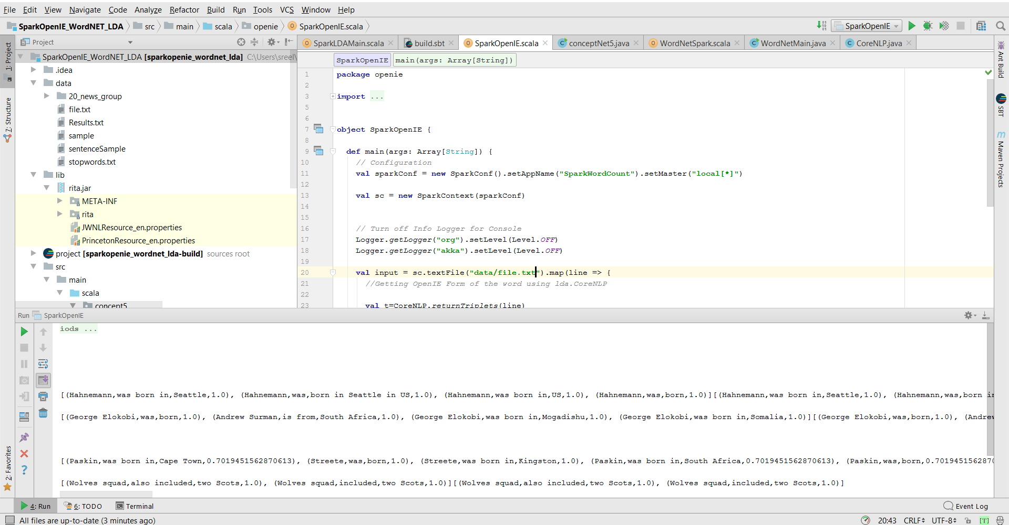

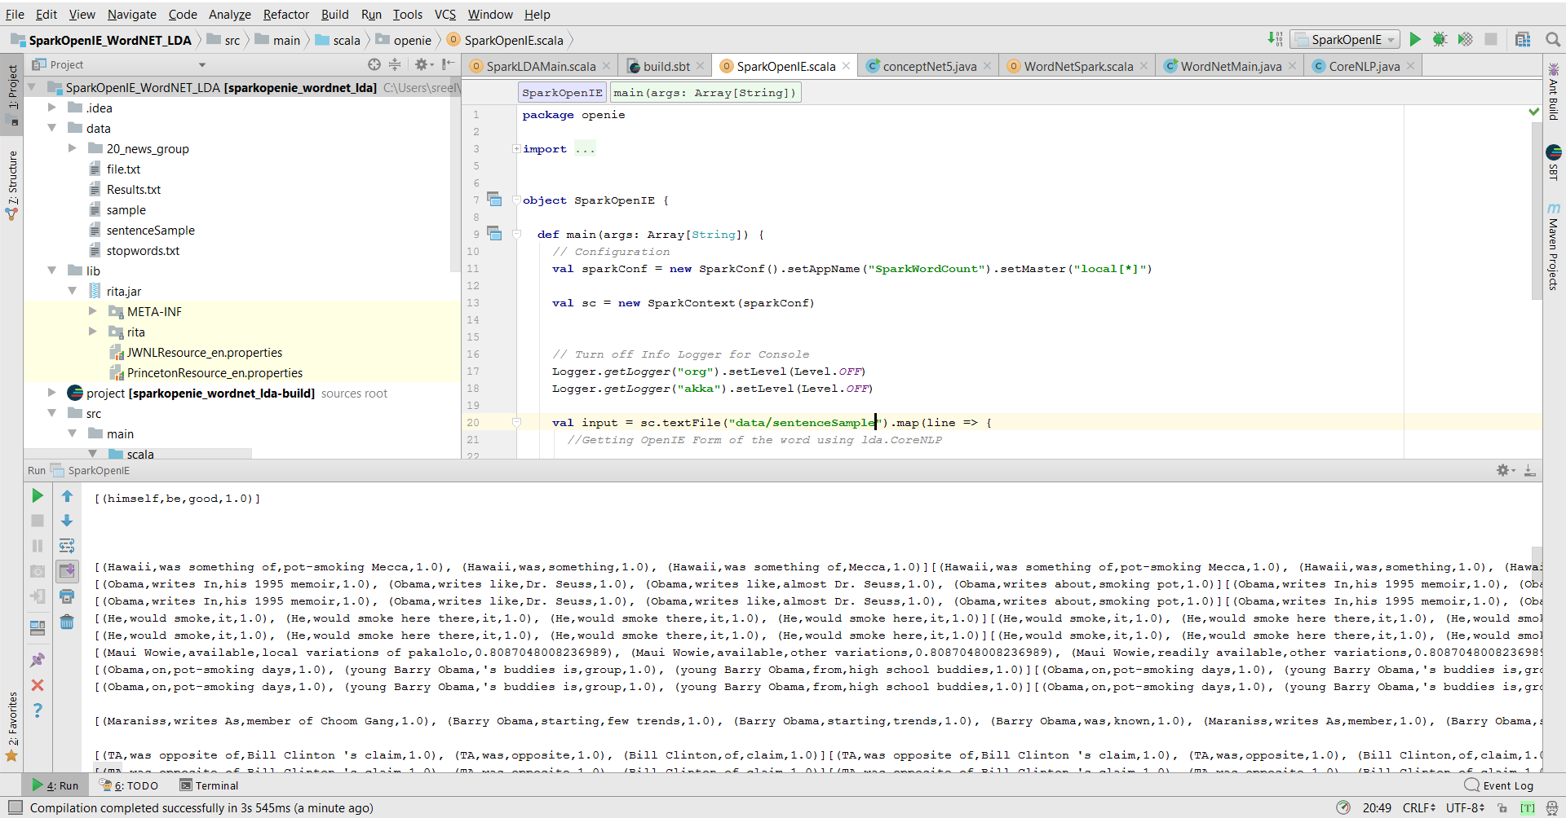

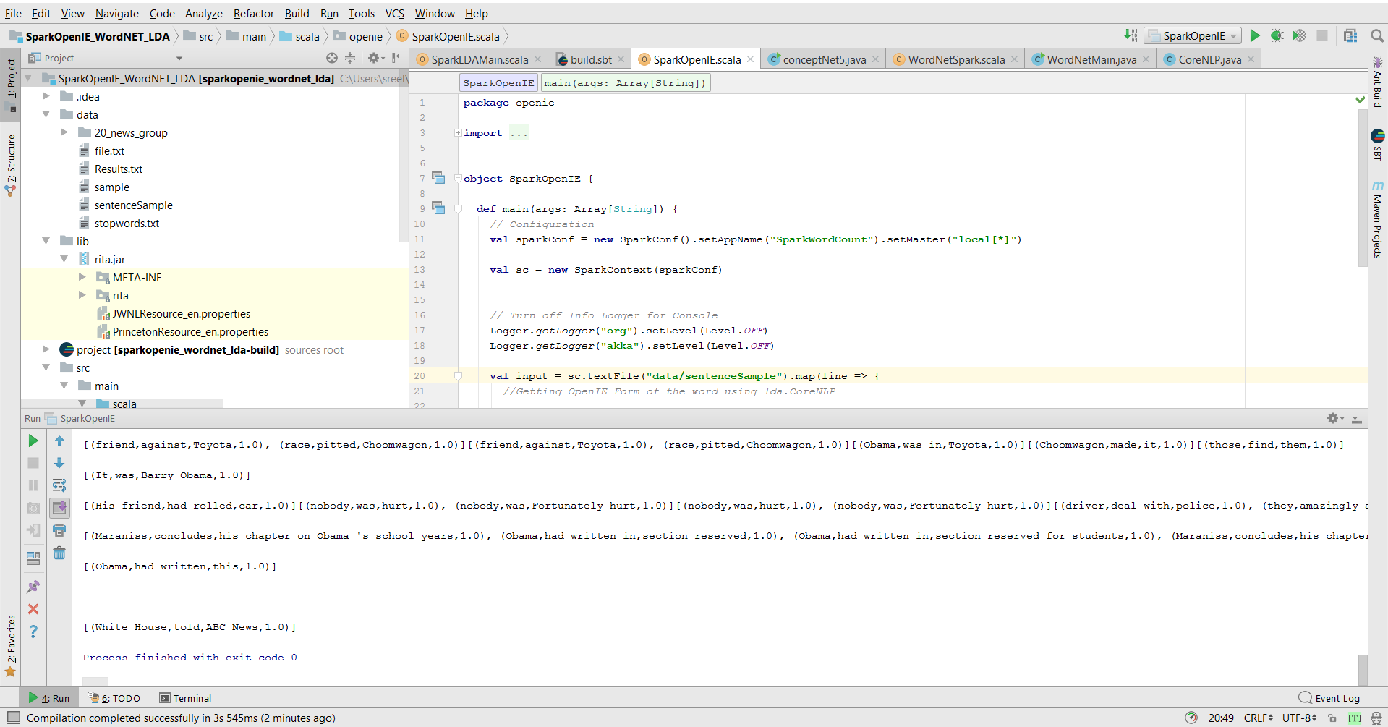

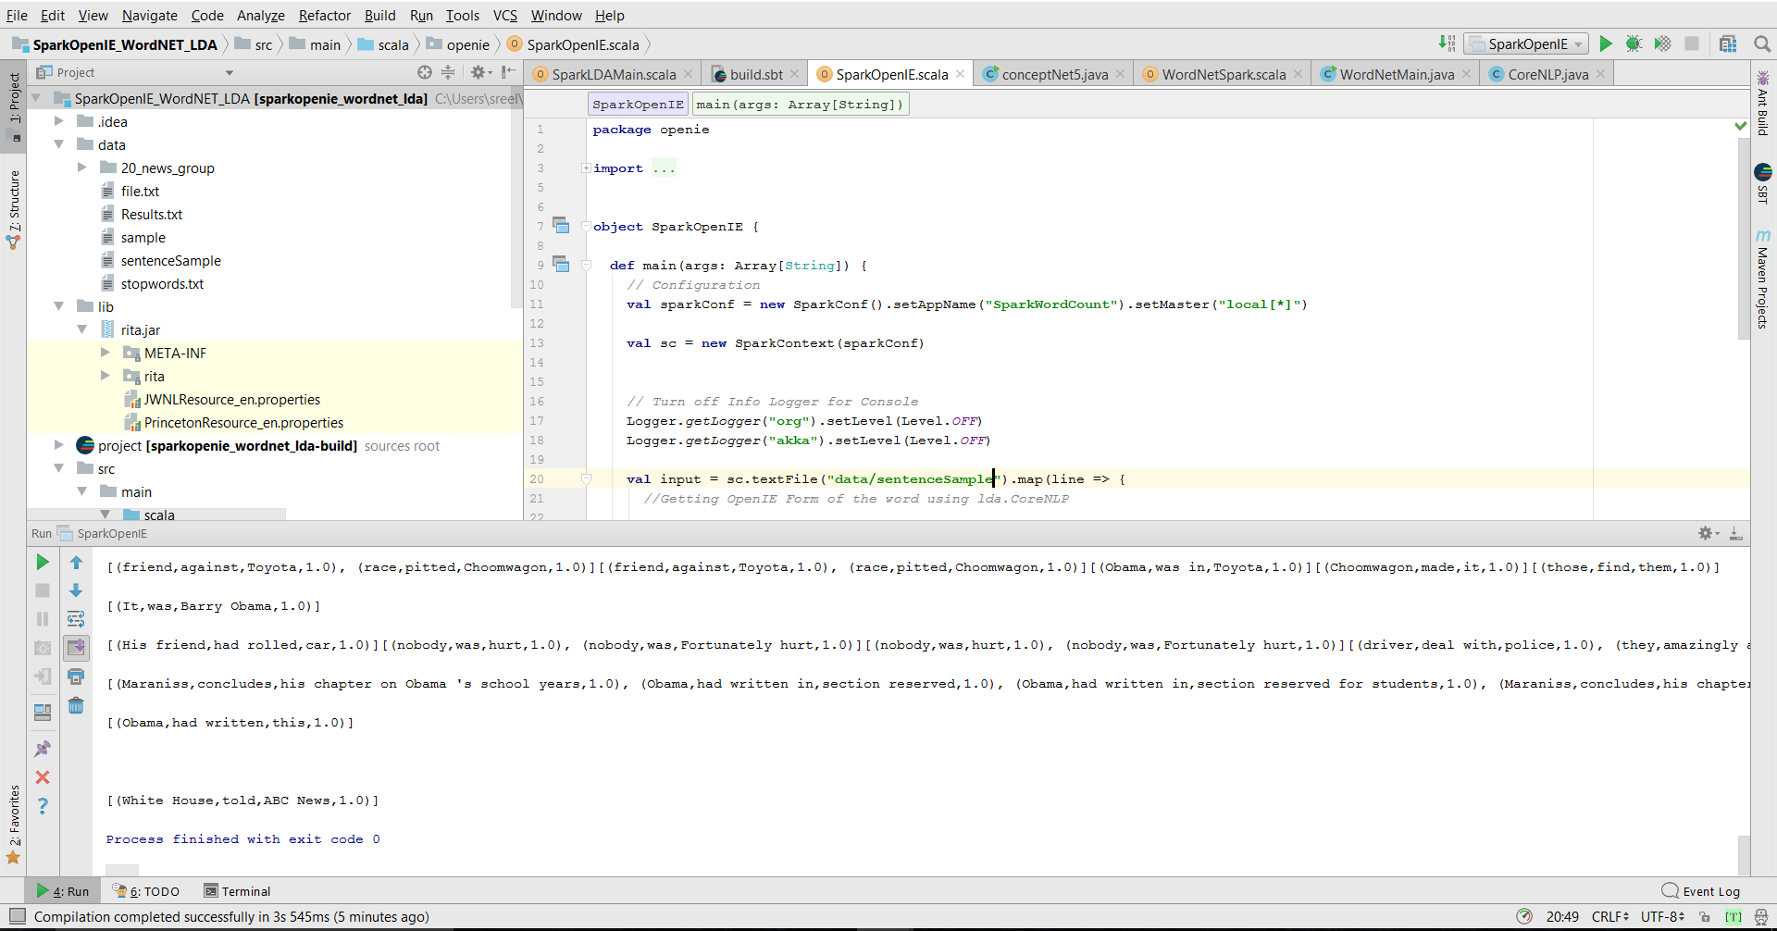

**Wordnet for our dataset**

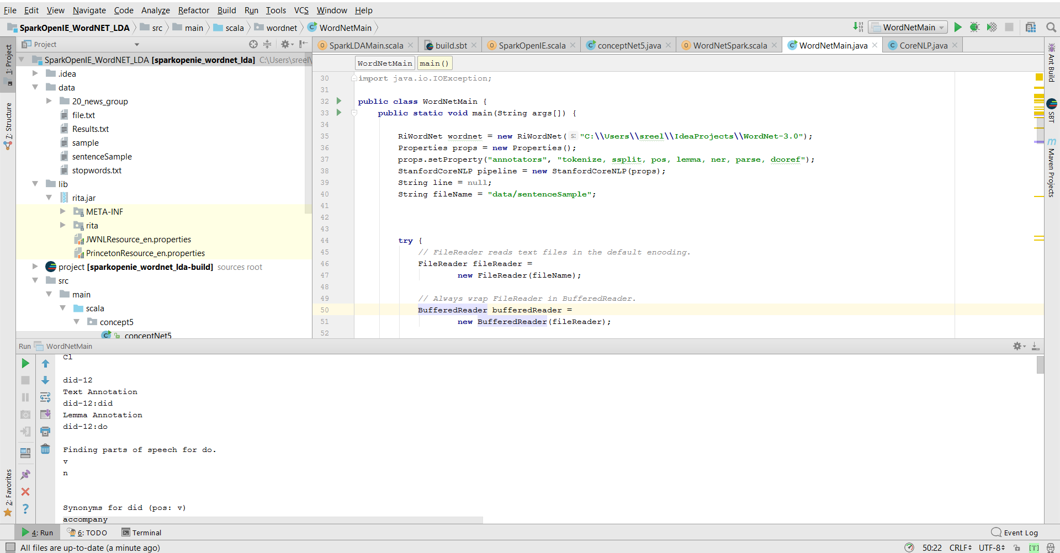

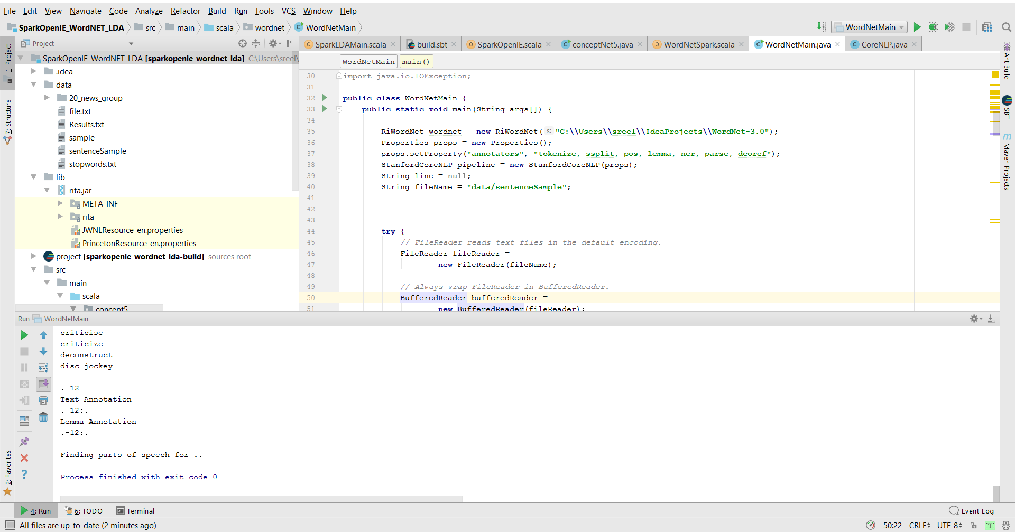

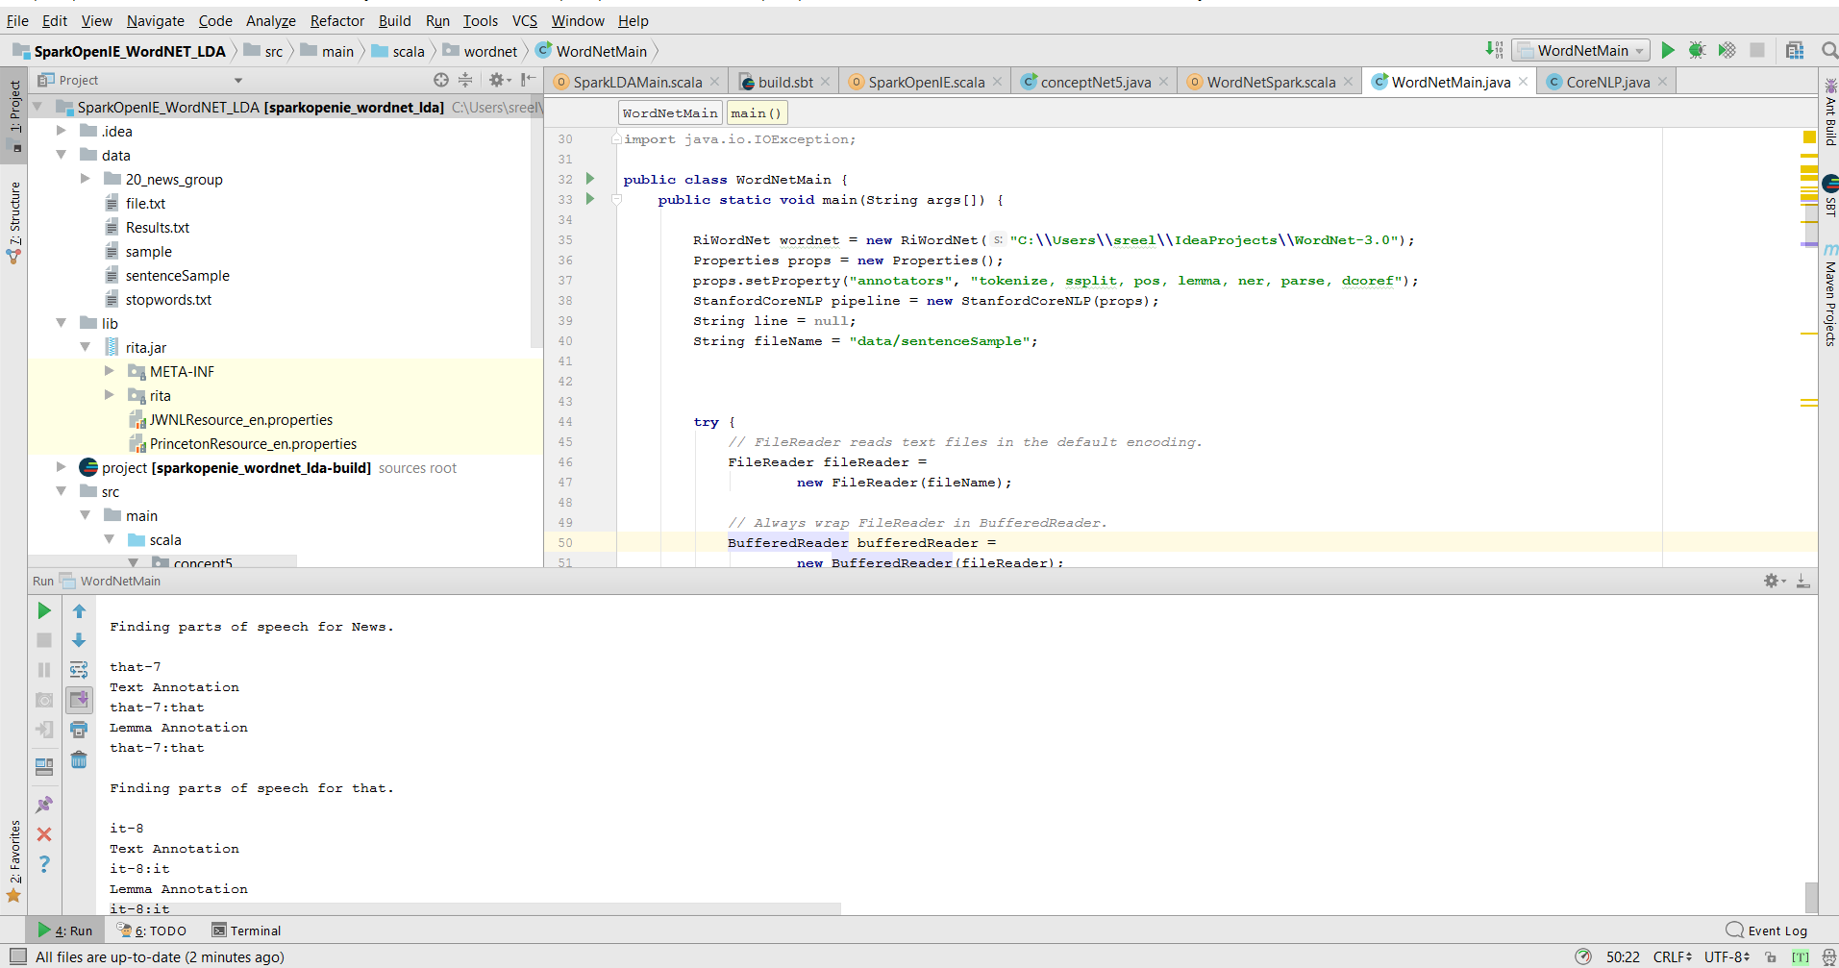

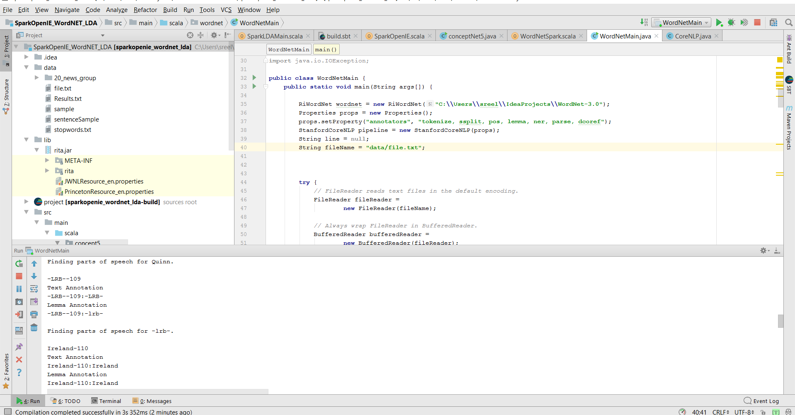

# 7. Project Management

## Programming Language Used:

We have collaborated various languages in the development of the project and in building the application. Some of them are,

* Java
* Scala
* Spark

## IDE Used:

Integrated development environments, helps in easy development of software with the facility of comprehensinve integereated enevironment.

* IntelliJ
* PyCharm

## 6.1 Contributors

* Jakkepalli, Rama Charan Pavan - **25%**
* Puthana, Sujitha - **25%**
* Yalamanchili, Sowmya **- 25%**
* Nandanamudi, Sreelakshmi **- 25%**

|  |  |  |
| --- | --- | --- |
| **Name** | **Implementation** | **Documentation** |
| Pavan | **Increment-1:** Basic Question Answer System  **Increment-2** | **Increment-1:** Domain, Specific Dataset,  Future Work  **Increment**-2: |
| Sujitha | **Increment-1:**  TF-IDF  **Increment-2**  TF-IDF question and answer | **Increment-1:** Design workflow, Question Answer, Knowledge Graph  **Increment-2**  Added more description to document, related work |
| Sowmya | **Increment-1:** Core NLP  **Increment-2** | **Increment-1:** Project Motivation, Objective, Significance.  **Increment-2** |
| Sreelakshmi | **Increment-1:** Named Entity Recognition  **Increment-2** | **Increment-1:** Contribution, Milestone, issues creation, Work Completed  **Increment-2** |

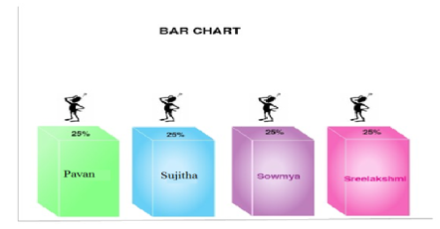

## 6.2 Zen-Hub Screenshots

For the first increment, we had issues regarding the working of the questions and answers section and generating the NLP output for the dataset we have chosen as the size of the dataset is larger.

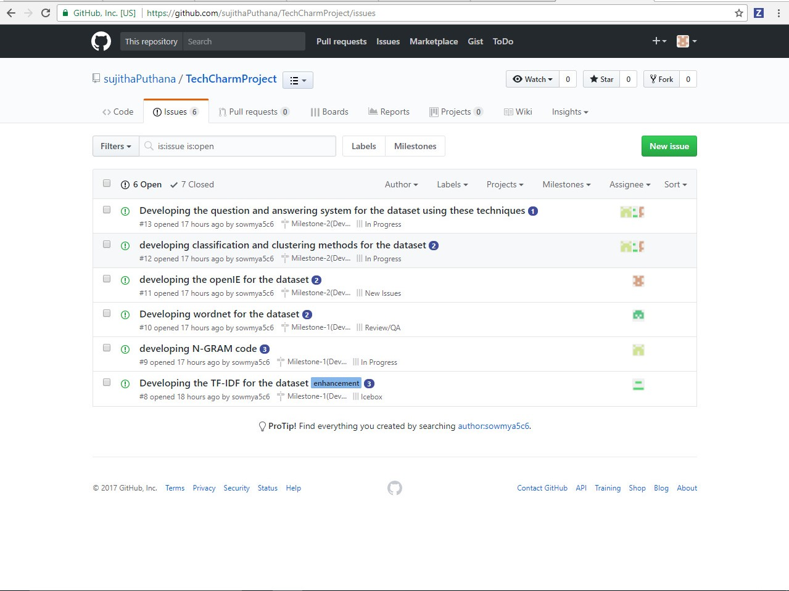

## Project Timeline, Members, and Task Responsibility

The issues that are registered and current one’s which we are working are updated and can be viewed in GitHub repository. The below screenshot will show you the issues and their respective categorization’s i.e. New issues, Icebox, Backlog, In Progress.

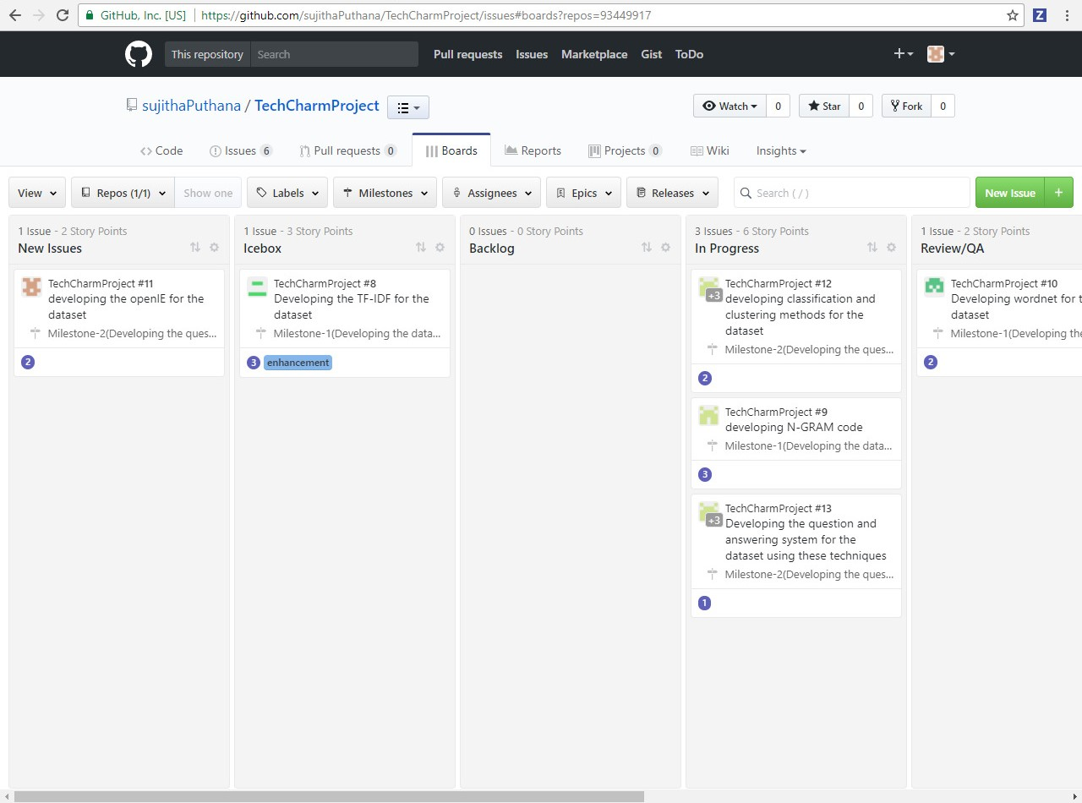

**Burn-Down Chart:**

Burn-Down chart is created for the above issues via Milestones in GitHub. Below is the screenshot for more information,

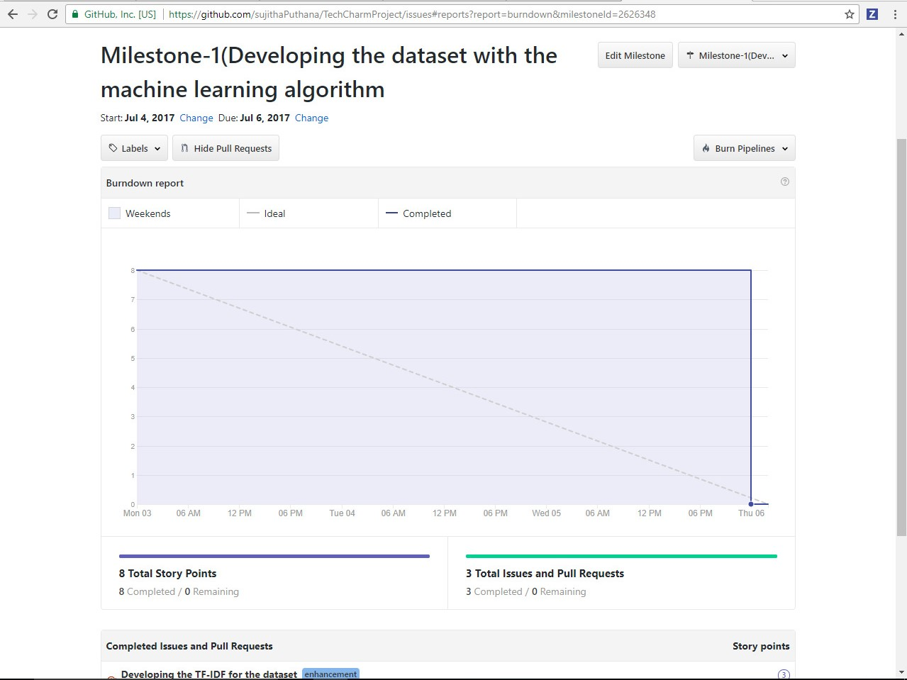

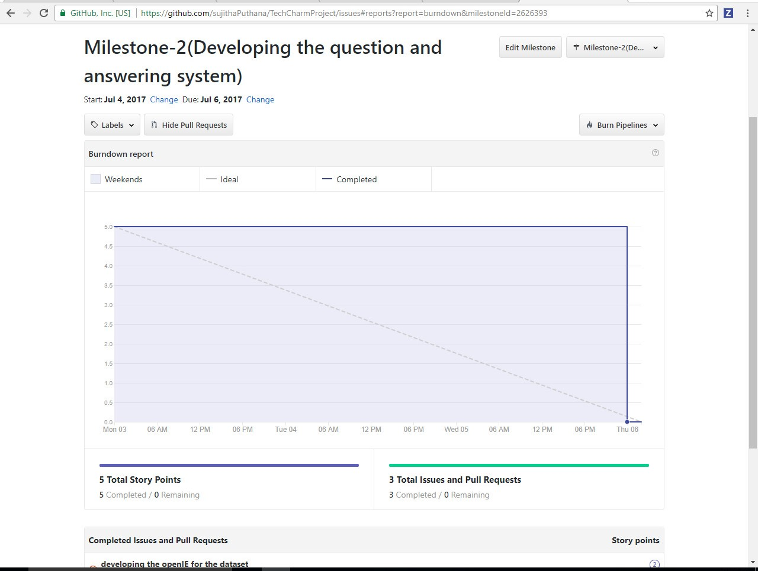

## GitHub Wiki Page

The GitHub wiki page URL for the screenshots and the process flow is updated in the following link

• https://github.com/sujithaPuthana/TechcharmProject

## 6.3 Work Completed

The completed tasks in this increment are,

* Performed the NLP operations on the dataset.
* Designing the question and answers for the NLP output.
* TF-IDE and N-gram analysis

## 6.3 Future Work

## We need to implement the question and answer approach using the TF-IDF integrated with the NLP operations.

* Need to integrate the TF-IDF approach with the N-GRAM and Word2Vec for better performance.

## Bibliography

1. <https://blog.algorithmia.com/introduction-natural-language-processing-nlp/>
2. <https://en.wikipedia.org/wiki/Question_answering>
3. <https://nlp.stanford.edu/>